PRACTICAL ASSIGNMENT

Class : Bca (AI\ML) 1B NAME= Kavya Sharma Group:1

Ǫ1= Create a simple html tag using basic tags?

<HTML>

<HEAD>

<TITLE> HELLO WORLD </TITLE>

</HEAD>

<body>

<H1> Your Name </h1>

</Body>

</html>

Ǫ2= Create a web page that displays your name to the screen?

<HTML>

<HEAD>

<TITLE> HELLO WORLD </TITLE>

</HEAD>

<body>

<H1> Kavya Sharma </h1>

</body>

</html>



**Ǫ3= Create a web page and show the output from 1 to 10 in separate lines?**

<HTML>

<HEAD>

<TITLE> HELLO WORLD </TITLE>

</HEAD>

<body>

1<br> 2<br> 3<br> 4<br> 5<br> 6<br> 7<br> 8<br> 9<br> 10<br>

</body>

</html>

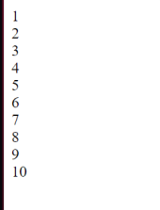

Ǫ4= Create a webpage and show the output from 1 to 10 in separate lines, each number being in different color?

<HTML>

<HEAD>

<TITLE> HELLO WORLD </TITLE>

</HEAD>

<body>

<font color="red"> 1 </font><br>

<font color="blue"> 2 </font><br>

<font color="yellow"> 3 </font><br>

<font color="brown"> 4 </font><br>

<font color="black"> 5 </font><br>

<font color="pink"> 6 </font><br>

<font color="purple"> 7 </font><br>

<font color="orange"> 8 </font><br>

<font color="grey"> 9 </font><br>

<font color="green"> 10 </font><br>

</body>

</html>



Ǫ5= how to make a picture as a background on my web pages?

ANS=

<HTML>

<HEAD>

<TITLE> HELLO WORLD </TITLE>

</HEAD>

<body>

<body background="C:\Users\student\Downloads/download.jpg">

</body>

</html>



Ǫ6=Create a web page to print a paragraph with 4-5 sentences, each sentences shall have a different font?

**Ans=** <html>

<head>

<title> BCA IB </title>

</head>

<body>

<h1>kavya sharma</h1>

<P>

<B>My name is Kavya Sharma</B><br>

<I>I am Currently studing in manav rachna international institute of research and science. It is situated in

Badkhal, Faridabad. </I>

<br> <U> My course that i am pursuing right now is BCA(AI/ML) </U>.

<br><B> My Hobbies are singing and watching movies and sometimes i go to play ludo and more indoor games with My family.</B><br>

</p>

</body>

</html>

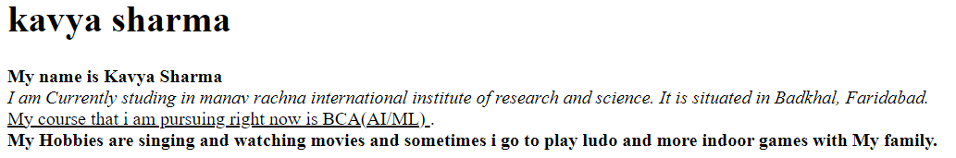

Ǫ7=write HTML code to print a paragraph that is described of a book, it shall include the title should be underlined and all adjectives shall be bold and italics?

<HTML>

<HEAD>

<TITLE>BOOK </title>

</head>

<Body>

<H1><u><b> Title Of The Book:Baby Boss</b></u></H1>

<p><i> Author Name: Marla Frazee<br></i>

<i>The Boss Baby is a 2017 movie about a 7-year-old boy named Tim who discovers that his new baby brother is actually a spy on a secret mission. Plot. In the 1980s, Tim Templeton, a creative 7-year-old, is taken aback when his new baby brother, Boss Baby, arrives. Baby wears a suit and tie and acts like a normal baby around parents and adults, but walks and talks like an adult when parents are absent

.</i></P>

</p>

</body>

</html>

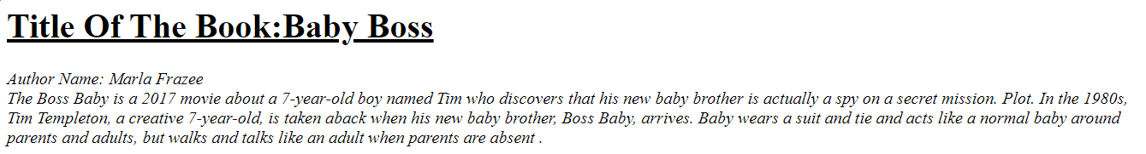

<HTML>

<HEAD>

<Title> Kavya sharma </Title>

</HEAD>

<BODY>

<H1> K</h1>

<H2> A</h2>

<H3> V</h3>

<H4> Y</h4><br>

<H5> A</h5>

<H1> S</h1>

<H2> H</h2>

<H3> A</h3>

<H4> R</h4>

<H5>M</h5>

<H6>A</h6>

</body>

</html>

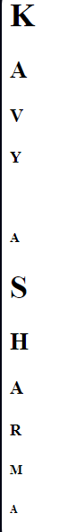

Ǫ9:Write Html code to print the sequence of number 1-20. each no shall be in

different line with number 2 next to it as subscript, an equal sign and the result? Ans: <html>

<head>

<title>Number Sequence</title>

</head>

<body>

<p>1<sub>2</sub> = 1</p>

<p>2<sub>2</sub> = 4</p>

<p>3<sub>2</sub> = 9</p> <p>4<sub>2</sub> = 16</p> <p>5<sub>2</sub> = 25</p> <p>6<sub>2</sub> = 36</p> <p>7<sub>2</sub> = 49</p> <p>8<sub>2</sub>

= 64</p> <p>9<sub>2</sub> = 81</p>

<p>10<sub>2</sub> = 100</p> <p>11<sub>2</sub> = 121</p> <p>12<sub>2</sub> = 144</p> <p>13<sub>2</sub> = 169</p> <p>14<sub>2</sub> = 196</p>

<p>15<sub>2</sub> = 225</p> <p>16<sub>2</sub> = 256</p> <p>17<sub>2</sub> = 289</p> <p>18<sub>2</sub> = 324</p> <p>19<sub>2</sub> = 361</p>

<p>20<sub>2</sub> = 400</p> </body>

</html> Output:

Ǫ10. wtrite an html code to display an image with border of size with width 200 height 200 pixels , leaving Hspace and Vspace of your choice with image hanging in the right side on the screen.

Ans: <HTML>

<head>

<title>Image Display</title>

<style> img {

border: 2px solid black; width: 250px;

height: 250px; display: block;

margin-left: auto; margin-right: 0; margin-top: 20px; margin-bottom: 20px; }

</style>

</head>

<body>

<img src="C:\Users\student\Downloads/jerry-zhang-nxu_VUcBVdA-unsplash.jpg" alt="Sample Image">

</body>

</html> Output:

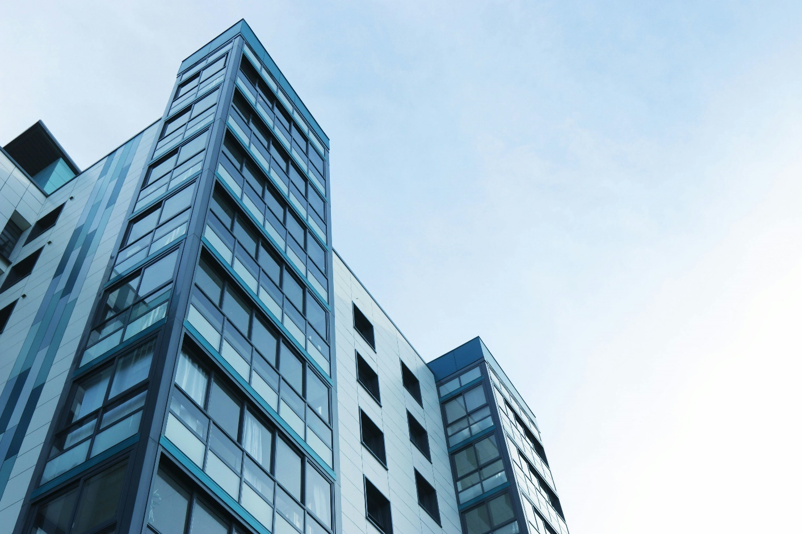

Ǫ11: write a html code to create a web page with heading. the heading shall be

displayed at the top-centre of the page and the image shall be at the centre , just below the heading .

INPUT- <html>

<head>

<title>Centered Heading and Image</title>

<style> body { margin: 0;

font-family: Arial, sans-serif; text-align: center;

justify-content: center;

align-items: center;

</style>

</head>

<body>

<h1>The Triumph of India 2024</h1>

<img src="C:\Users\Riaz\Downloads/riaz.jpg" alt="scenery" height="450" , width='450'>

</body>

</html> Output:

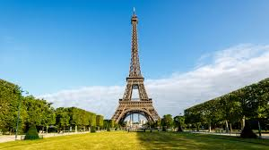

Ǫ13: Create a Table using Rowspan and Colspan taking example of student Record?

Ans:

1. rowspan

<html>

<head>

<title> my world </title>

</head>

<body>

<h1> table </h1>

<table border="2">

<tr>

<th> name</td>

<th> roll no</td>

</tr>

<tr>

<td >Kavya</td>

<td rowspan="2">23</td>

</tr>

<tr>

<td> Arjit</td>

</tr>

</table>

</body>

</html>

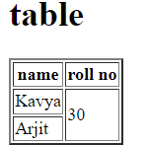

Colspan:

<html>

<head>

<title> my world </title>

</head>

<body>

<h1> table </h1>

<table border="2">

<tr>

<th> name</td>

<th> roll no</td>

<th> class</th>

</tr>

<tr>

<td >Kavya</td>

<td colspan="2">30</td>

</tr>

<tr>

<td> Ishi</td>

<td> 19</td>

<td> bca </td>

</tr>

</table>

</body>

</html>

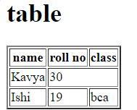5

Ǫ14: Write HTML code using table tag <table> and cellpadding and cellspacing as its attributes?

<html>

<head>

<style> table, th, td { padding : 15;

Spacing : 15;

}

</style>

</head>

<body>

<table border="1">

<tr>

<th> Name </th>

<th> Class </th>

<th> Roll No. </th>

</tr>

<tr>

<td> Kavya</td>

<td> 1B </td>

<td> 30</td>

</tr>

<tr>

<td> Anju </td>

<td> 1B </td>

<td> 31 </td>

</tr>

</table>

</body>

</html>

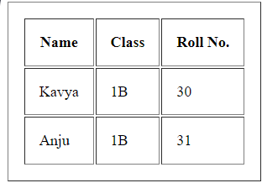

Ǫ15: Create unordered, ordered and definition Lists taking example of your subjects in MCA IST, IInd and IIIrd Semester?

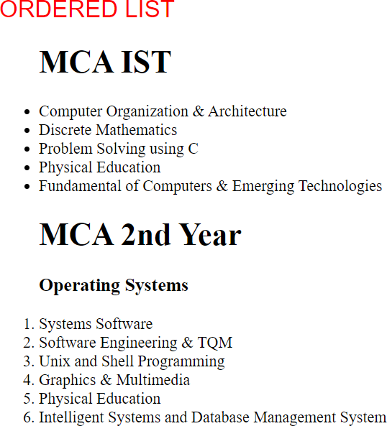

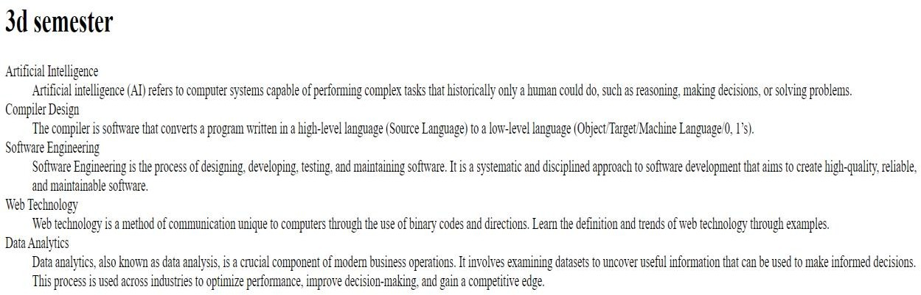

Ǫ17:Write HTML code to design a form in HTML using controls and buttons such as Textbox , Text area,

password, submit button, browse button, drop-down menu? Ans: <html>

<body>

<h1> FORM </h1>

<fieldset>

<label for="name">Name:</label>

<input type="text" id="name" name="name" required/>

<br><br>

<label for="name">Name:</label>

<input type="text" id="name" name="name" required/>

<br><br>

<label for="Password">Password:</label>

<input type="Password" id="Password" name="Password" required/>

<br><br>

<label for=”file">File</label>

<input type="file" id=" file " name=" file " required/>

<br><br>

<h3> text area</h3>

<textarea cols="50" rows="5"/></textarea><br><br>

<button type="submit">Submit</button>

<button type="reset">Reset</button><br><br>

<select id="cars" name="cars">

<option value="Creta" id="cars" name="cars">Creta</option>

<option value="Brezza" id="cars" name="cars">Brezza</option>

<option value="Mustang" id="cars" name="cars">Mustang</option>

</select>

</fieldset>

</form>

</body>

</html>

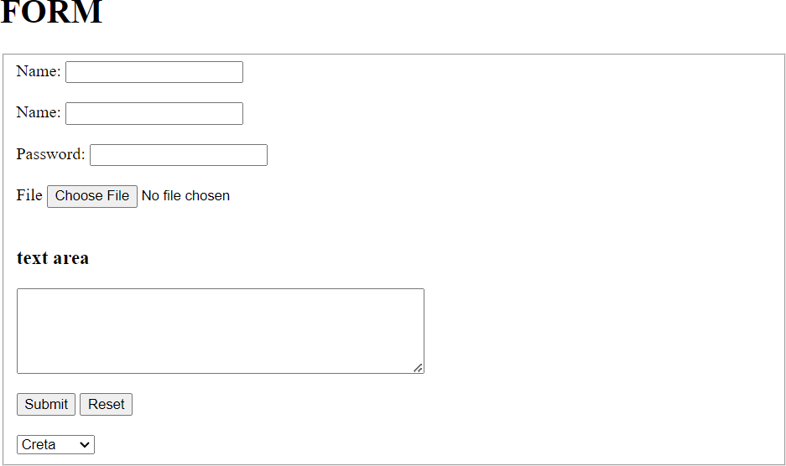

Ǫ18) Write HTML code to design a Registration Form in HTML.

<html>

<head>

<title>Registration form for Hackathon</title>

</head>

<body>

<form>

<fieldset>

<legend>Hackathon Registration</legend>ss Name<br>

<input type ="text"/><br> Email id<br>

<input type="email"/><br> Age<br>

<input type="radio" name="rad"/> 17-19

<input type="radio" name="rad"/> 19-21

<input type ="radio" name="rad"/>21-24<br> Languages available<br>

<input type="checkbox" name="check"/>Html

<input type="checkbox" name="check"/>Css

<input type="checkbox" name="check"/>Java<br>

<button>Submit</button>

<button>Reset</button>

</fieldset>

</form>

</body>

</html>

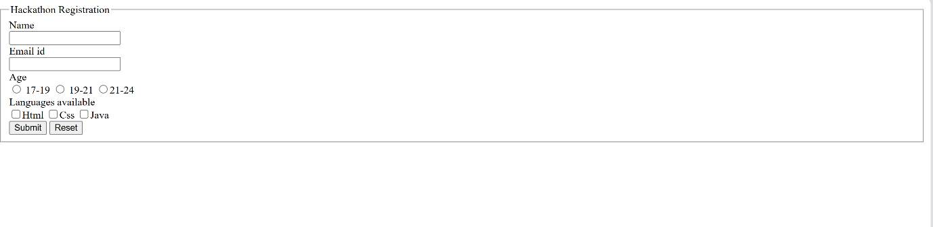

Ǫ19) Write HTML code to design a student admission Form in HTML.

<html>

<head>

<title>College Registration form</title>

</head>

<h1>College Registration Form</h1>

<body>

<Form>

<fieldset>

Full name<br>

<input type="text"/><br> Age<br>

<input type="radio" name="rad"/>17-19

<input type="radio" name="rad"/>19-21

<input type="radio" name="rad"/>21-24<br> Gender<br>

<input type="radio" name="radi"/>Male

<input type="radio" name="radi"/>Female

<input type="radio" name="radi"/>Others<br> Date of Birth:<br>

<input type="Date" name="dat"/><br> Phone number<br>

<input type="text"/><br> Father's Contact number<br>

<input type="text"/><br> Mother's Contact number<br>

<input type="text"/><br> Email id<br>

<input type ="email"/><br> Address<br>

<input type="text"/><br> Ǫualification<br>

<input type="radio" name="rad">12th pass

<input type="radio" name="rad">Graduation<br> Cbse 12th Marksheet<br>

<input type="file"/><br> Choose Course<br>

<input type="checkbox" name="check"/>BCA

<input type ="checkbox" name="check"/>B.Tech.

<input type ="checkbox" name="check"/>B.com

<input type ="checkbox" name="check"/>Bba<br>

<button>Submit</button>

<button>Reset</button>

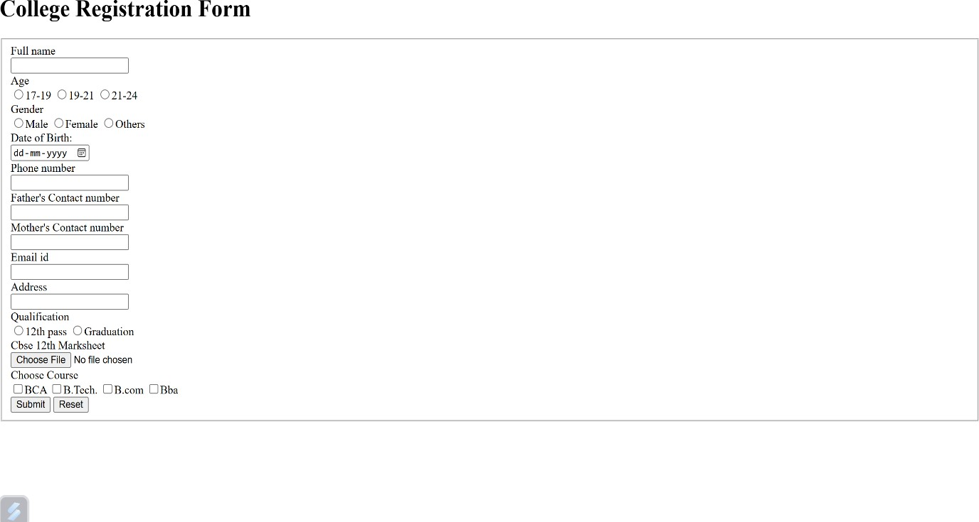

Ǫ20) Create a proper home page of your own using any components and styles.

<html>

<head>

<style>

<html>

<head>

<style> H1 {

text-align: left; color: black;

}

p {

text-align: center;

color: purple;

}

#para1{ text-align: right; color:brown;

}

.center{ text-align: center; color: grey;

}

</style>

</head>

<body>

<h1> LINKEDIN </H1>

<p id ="para1">Connect to opportunity.</p>

<p class="center">Unlock your potential</p>

<p> Free trial for 3 months</p>

</body>

</html>

